Acquiring GCP Credentials

1. Creating a service account key
   * From the Main dashboard, click on the menu button in the top left corner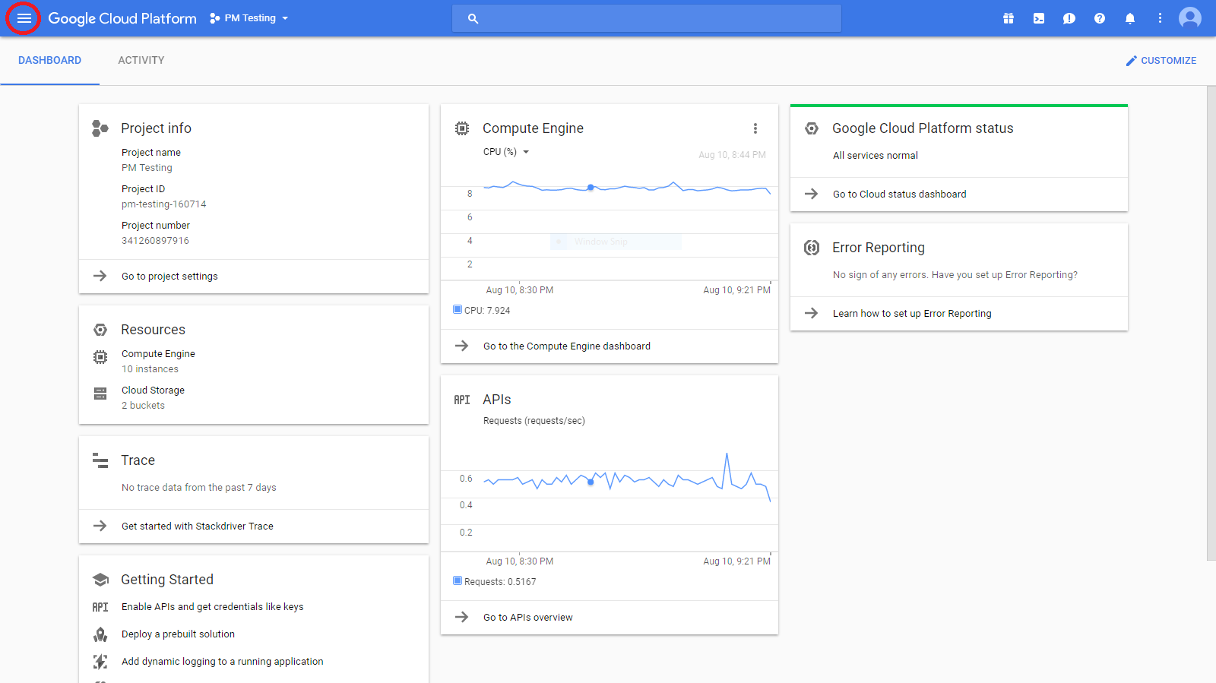
   * Mouse over APIs & Services and select Credentials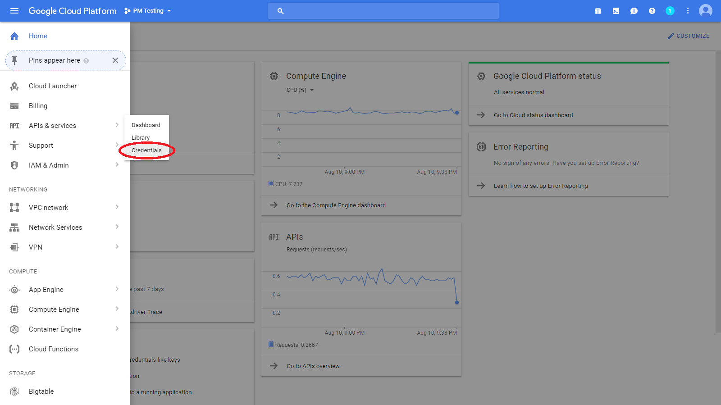
   * Click Create Credentials and select Service account key
     1. If the option is unavailable, contact the project owner to attain “Editor” permissions within the project
   * Set Service account to “Compute Engine default service account” and set Key type to JSON and click Create.
   * Place the credential file into root folder of data collection program.
2. Ensuring service account privileges
   * Use the Menu button to access “IAM & Admin” and ensure that the “Compute Engine default service account” is listed with viewer role(s) or higher.

If account is not listed:

* + 1. Select service accounts from the left-side menu and copy the “Service account ID” associated with the “Compute Engine default service account.”
    2. Select IAM from the left-side menu, select “ADD” at the top and paste the Service account ID into “Members” and set “Roles” to Editor (Project > Editor)

1. Ensuring project has an associated Stackdriver account and checking service tier
   * In the left-side menu, scroll down and select “Monitoring” under the “Stackdriver” subtitle.
   * If the prompt states “(project name) is not in a Stackdriver account”, Go through “Creating a Stackdriver account” in the [Google Documentation](https://cloud.google.com/monitoring/accounts/guide) from step 4 onward then continue here.

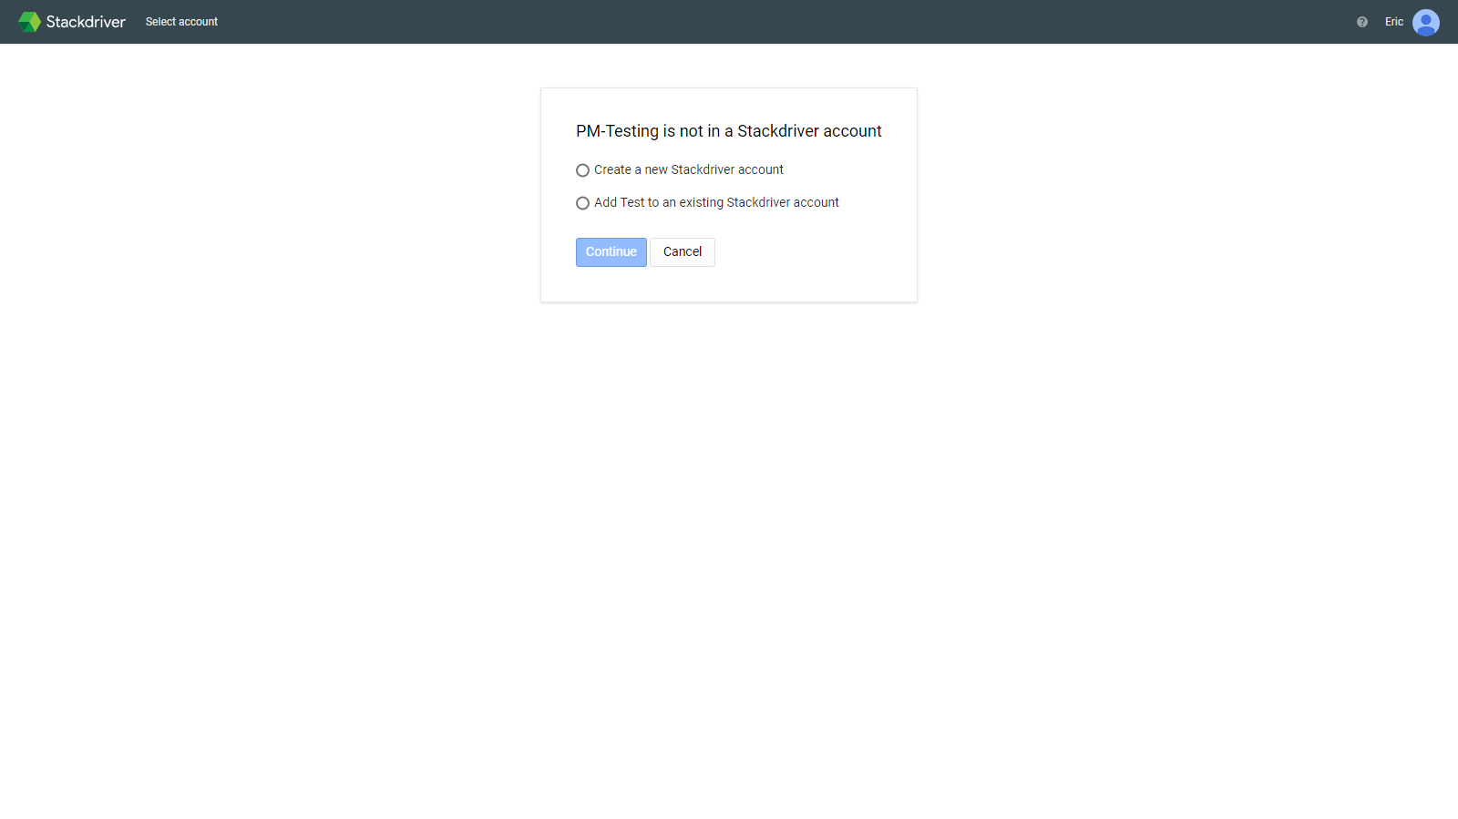

* + Once it opens the Stackdriver homepage, at the top select the project name > manage accounts.
  + Note the billing plan of the current project for later. (Premium Trial treated as normal premium account)

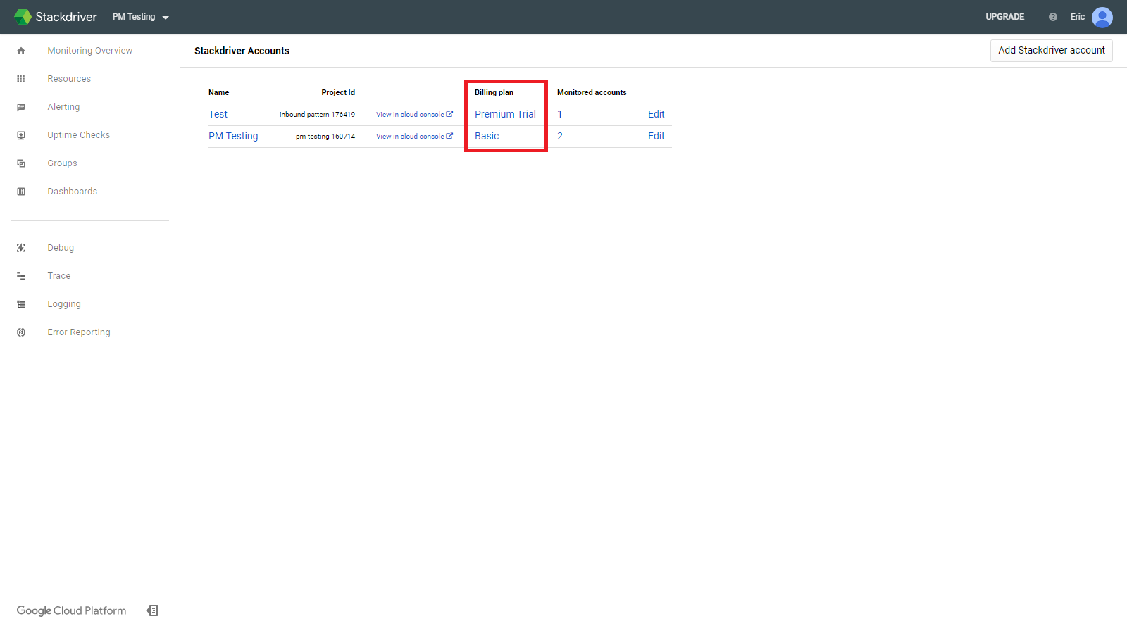

1. Ensure required APIs are enabled.
   * Select “APIs & services” from the left-side menu and ensure Stackdriver Monitoring API, and Google Cloud Resource Manager API are both listed.
   * If either is not listed, select “Library” from the left-side menu, and search for each missing API and enable it.
2. Repeat steps 1-5 for each populated project.

**Potential Troubleshooting**

If Compute Engine default service account does not exist, the user does not have any instances or has not created any through the console. They will need to create an instance for the default service account to be automatically generated.